What is Cloud Computing?

- Cloud Computing is the practice of using a network of remote servers (machines/computers) hosted on the internet to store, manage, and process data/information, rather than your local computer.
- What is the cloud?
- Someone else’s computer connected to the internet. Basically.
- That “someone else” is probably a company that’s charging you to use their computer to store your vacation photos, host a website, and a ton of other use cases.

- There is no single “cloud”, but rather many companies providing Cloud Computing Services with their own infrastructure (servers etc.).
  - And yes, you could set up your own infrastructure to host websites and stuff on your own. But it’s way less feasible than something like:

AWS (Amazon Web Services)
- Amazon Web Services (AWS) is a collection of hundreds of cloud computing services that provide the building blocks for IT infrastructure
- “AWS is a cloud provider” - It provides cloud resources, usually for a fee.

- Think of it as Amazon filling a niche in our field
- A small business (or an individual developer) doesn’t need to buy a bunch of hardware and build everything from scratch just to develop one full stack application hosted on the web. Amazon provides all these assets for us, and we can rent them out (or use weaker free tier assets). It’s less hefty of an investment for us little people, and Amazon makes money off of us :)
- “AWS is a cloud provider that offers the building blocks of an IT infrastructure for individuals or companies to use”

- You pay only for what you use. This is pretty much always cheaper and faster than trying to run your own IT room.
- It’s Highly Scalable. You can easily upsize/downsize the tools you’re using.
- It’s Highly Available. Amazon has locations all over the world with resources for computing. (You can look up AWS availability zones to see where they have their resources)

AWS has taken over the world, as evidenced by this data visualization:
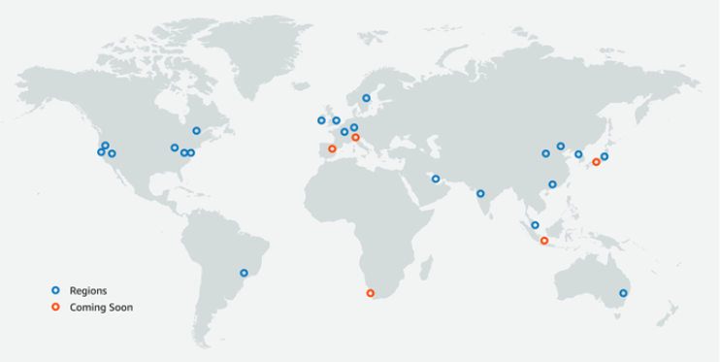

- AWS is the top dog in the “Big 3” cloud providers
  - AWS (Amazon): (Amazon Web Services - 31% of global market share)
  - GCP (Google): (Google Cloud Platform - 12% of global market share)
  - Azure (Microsoft): (~20% of global market share)

The Shared Responsibility Model
- AWS is responsible for some things, and we, the users, are responsible for others. AWS’s Shared Responsibility Model defines who owns and secured what aspect of a cloud architecture.
- AWS is responsible for the security OF the cloud
  - Physical hardware, data centers, the networking infrastructure, and anything else you can't access directly. If Amazon's servers catch fire, that's everyone’s problem, but their responsibility.
- You are responsible for the security IN the cloud
  - What you put in there, how you configure it, who has access to it, and how secure it all is. If you misconfigure your database and expose customer data, that's you and your customer’s problem, and it’s your responsibility.
The 3 Cloud Computing Models
- These are three types of cloud services. The types are defined by how much of the stack the cloud provider manages for you versus how much you handle yourself.
  - As we go through these, note how the Models range from raw infrastructure all the way up to a finished product.
Infrastructure as a Service (IaaS)
- This model includes infrastructure-level technology. This includes virtual machines, file-based storage, firewalls (security groups), load balancers, virtual local area networks, and more.
- Examples include Amazon EC2 or Amazon S3. We get a server that we have to configure and maintain ourselves. Essentially a virtual computer and nothing else.
Platform as a Service (PaaS)
- This model is used to provide cloud infrastructure to software you’ve written. These services include automatic server and database management platforms.
- Examples include AWS RDS, which provides a server for us after we configure the database.
- Also, AWS Elastic Beanstalk, which we can use to deploy apps like we do with EC2s, but AWS handles the infrastructure (servers, etc.), and you just handle the application and its settings.
- Elastic Beanstalk will take your app (packaged into a deployable format) and create EC2s for you and deploy the app on them.
- You can also look into AWS Lambda, which is like a lightweight EC2 with a server you don’t have to directly manage (it’s considered “serverless” for this reason).
- Software as a Service (SaaS): In this model, complete cloud-based applications are provided to the user. It is a single instance of the service running on the cloud that multiple users can consume. This is essentially a “final product” that’s completely usable to a consumer without any config etc.
- You could say AWS.com is a SaaS that lets us manage different PaaS and IaaS services.
- The apps on your phone are software - SaaS
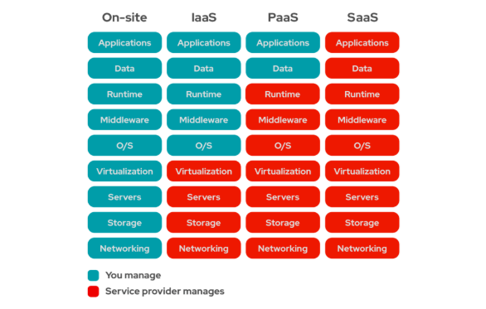
- I’ve found it useful to compare them to cars.
- IaaS: Leasing a car. You get the vehicle but you're responsible for gas, insurance, maintenance
- PaaS: Renting a car. It's gassed up and insured, you just drive it
- SaaS: Using rideshare apps: You don't manage anything, you just use the service and get picked up.
You’ll also find that the price increases in order from IaaS -> PaaS -> SaaS, just like the options in this car analogy.

There are also 3, easier to understand privacy models of cloud computing:
- Public
- Cloud computing run by a third-party cloud provider. (AWS!)
    - Use Case: Startups, solo devs, or any org that wants scalable infrastructure without owning any hardware themselves. Most web apps and SaaS products are public.
- Private
- The cloud computing services and infrastructure are hosted privately within a company’s intranet. The company owns and maintains the underlying hardware and doesn’t go through a third party at all.
    - Use Case: Enterprises or government agencies with strict security, compliance, or regulatory requirements.
- Hybrid
- Applications are running in a combination of different environments. (public & private)
    - Use Case: Orgs that keep sensitive data on private infrastructure but offload everything else to the public cloud. The example I see often is hospitals that store patient records on prem but do everything else through a cloud provider.

